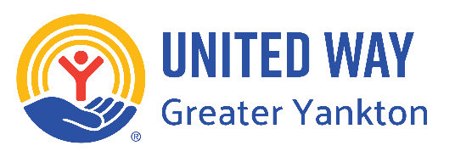
Put your logo in place of UW’s

Connecting Kids Youth Scholarship Family Request Form

Participant Name:
Age | DOB:
Activity/Program:
Parent/Guardian Name:
Phone:
Email:

Please briefly explain why scholarship assistance is being requested:

Household Eligibility (check all that apply):
Receives Free or Reduced School Meals
Receives SNAP/WIC Assistance
Receives Medicaid
Experiencing Financial Hardship
Other:

Parent/Guardian Certification

I certify that the information provided is accurate to the best of my knowledge.

Parent/Guardian Signature:

Date:

Agency Approval (Office Use Only)
Approved By:

Date:

